[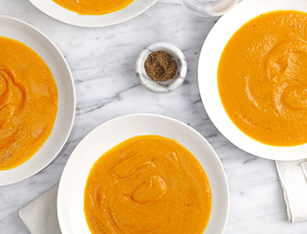](http://goop.com/recipes/roasted-clean-carrot-soup/)

**TIP**

**Choose a high-quality olive oil to drizzle on top at the end.**

**ROASTED + CLEAN CARROT SOUP**



**GOOP**

*The idea here is to slow roast and caramelize half the carrots and keep the other half super clean. This gives a complex, layered taste to a soup with basically just one main ingredient.*

**MAKES 4**

6 to 8 medium to large carrots (about 1.5 pounds), peeled and diced into rustic cubes

6 cups chicken or vegetable stock

1 piece ginger, an inch long, peeled

1 small onion (white or yellow), chopped

2 garlic cloves, whole

olive oil

salt + pepper, to taste

1. Divide the carrots in half. Place one half of the carrots on a baking sheet. Season with salt and pepper and drizzle lightly with olive oil. Toss to combine. Place in a 375°F degree oven for about 20 minutes, shaking the pan every so often for even cooking. Remove from oven when soft, slightly brown and caramelized.

2. Meanwhile, bring the stock to a boil in a large saucepan with the ginger, onion and garlic. Bring down to a simmer and cook for about 5 minutes or so until the onions are soft. Add the remaining half of the carrots and simmer for another 5 minutes until the carrots are just slightly soft but not cooked through. Transfer the mixture to a blender.

3. Add the roasted carrots to the blender with the par-boiled carrots. Blend until smooth. Add salt and pepper to taste and a drizzle of olive oil over each portion to serve.